WEB3 ESS LOGIN PAGE
- Forgot Password – completed api response is slow spinner enabled
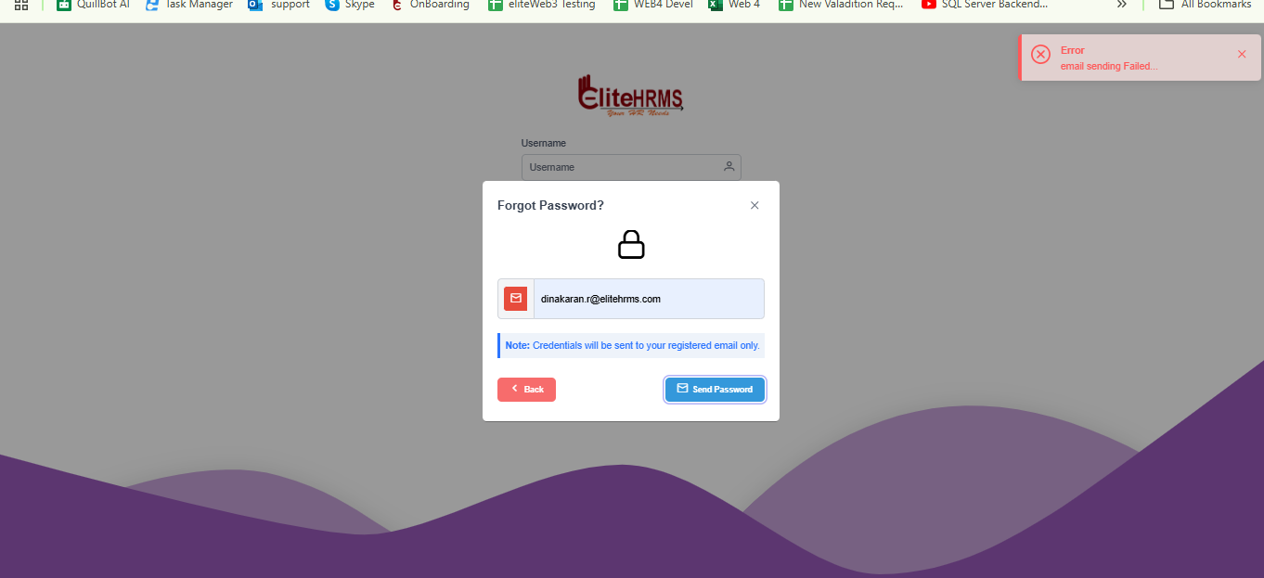

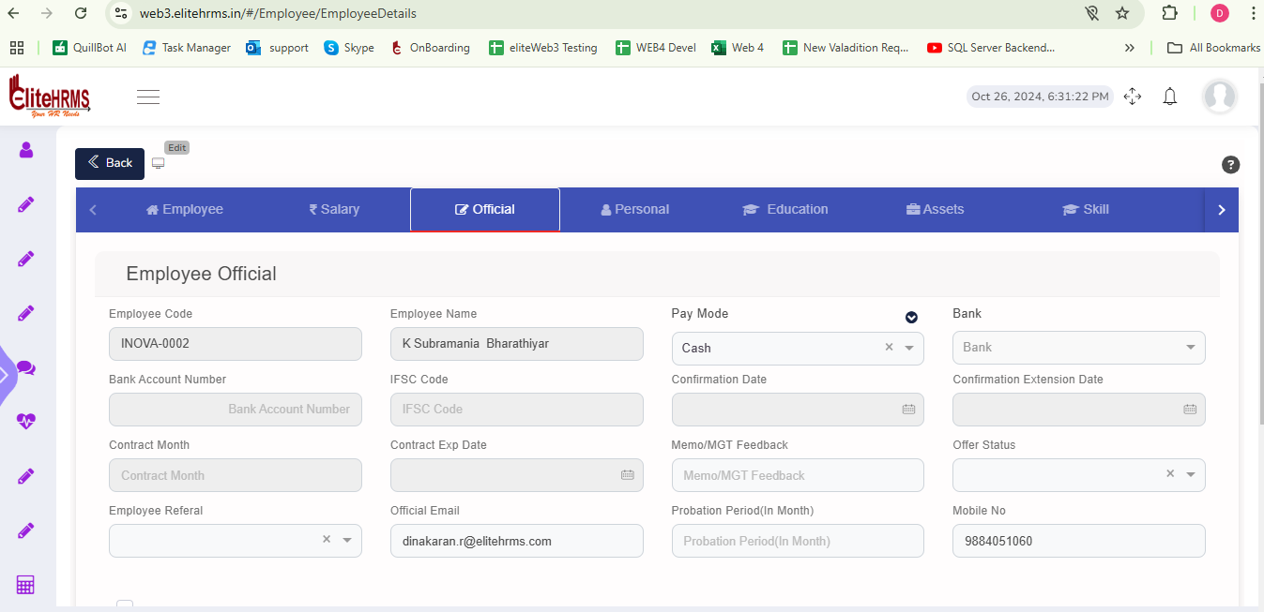

While Forgot Password to send the Email Fail
https://web3essapi.elitehrms.in/api/admin/GetForgetPassword?EmailID=dinakaran.r%40elitehrms.com

EmailID=dinakaran.r%40elitehrms.com

{
"Response": {
"_status": "Failed",
"_code": "552",
"_Source": "GetForgotPassword",
"_Description": "email sending Failed...",
"_Details": "MailID is MisMatched...",
"_TransID": null,
"_Timestamp": "20241026182953"
}
}

2. New user? Registers

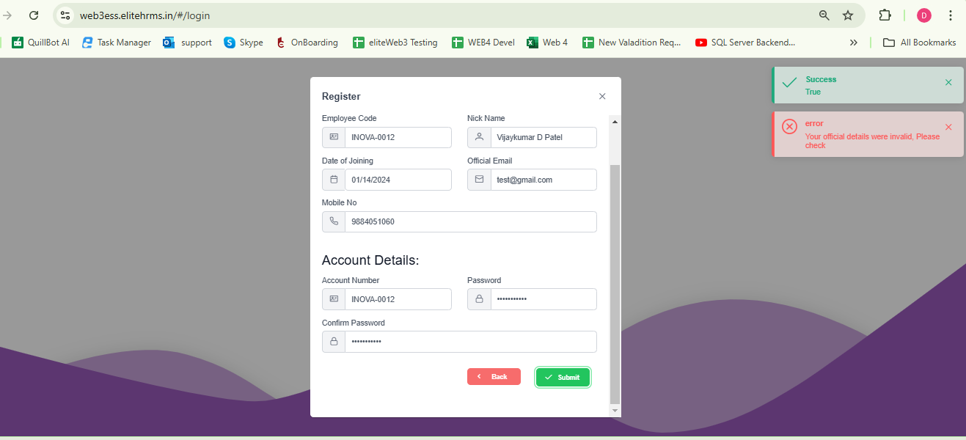
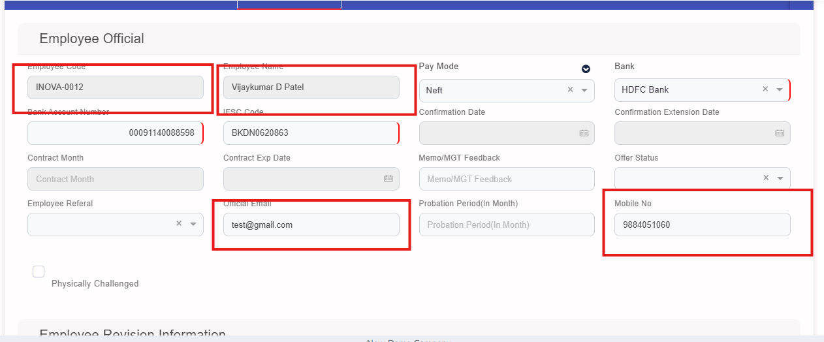
https://web3essapi.elitehrms.in/api/admin/PostSignUp

authorization

{"EmployeeCode":"INOVA-0012","UserName":"INOVA-0012","DisplayName":"Vijaykumar D Patel","Password":"Pass@123456","DOJ":"2024-01-14","EmailID":"test@gmail.com","MobileNo":9884051060,"TermsandConditionsFlag":1}

{
"Response": {
"_status": "Failed",
"_code": "333",
"_Source": "PostSignUp",
"_Description": "Your official details were invalid, Please check",
"_Details": "",
"_TransID": null,
"_Timestamp": "20241026183959"
},
"EmployeeCode": null,
"UserName": null,
"DisplayName": null,
"Password": null,
"DOJ": null,
"EmailID": null,
"MobileNo": null,
"TermsandConditionsFlag": null,
"TermsandConditionsDate": null
}
3 Login Page – Working Fine
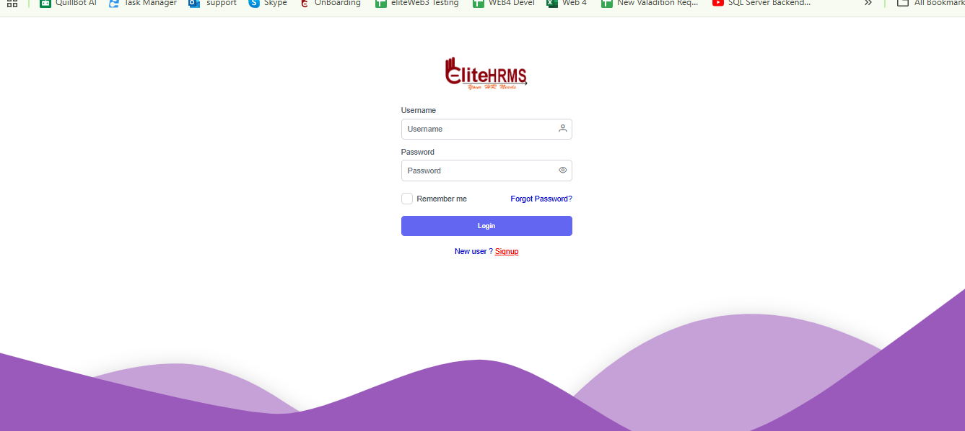

4. Logout - Working Fine

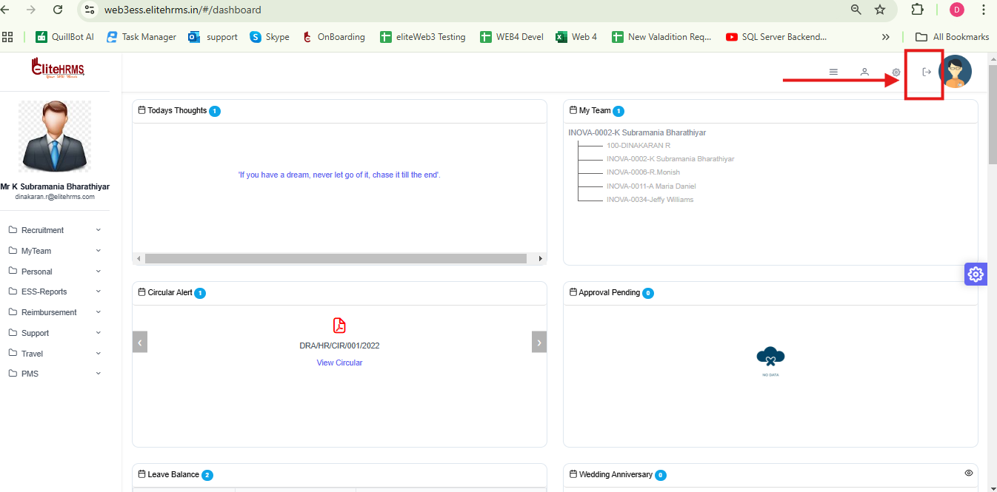

5. session time out - Working fine

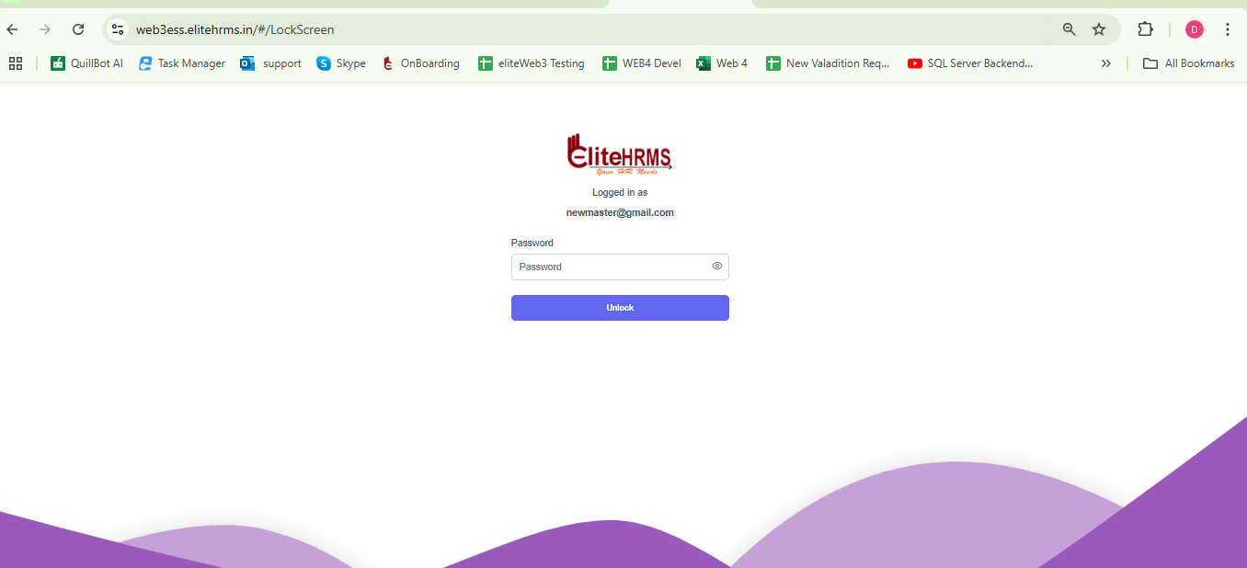

6. Leave Request

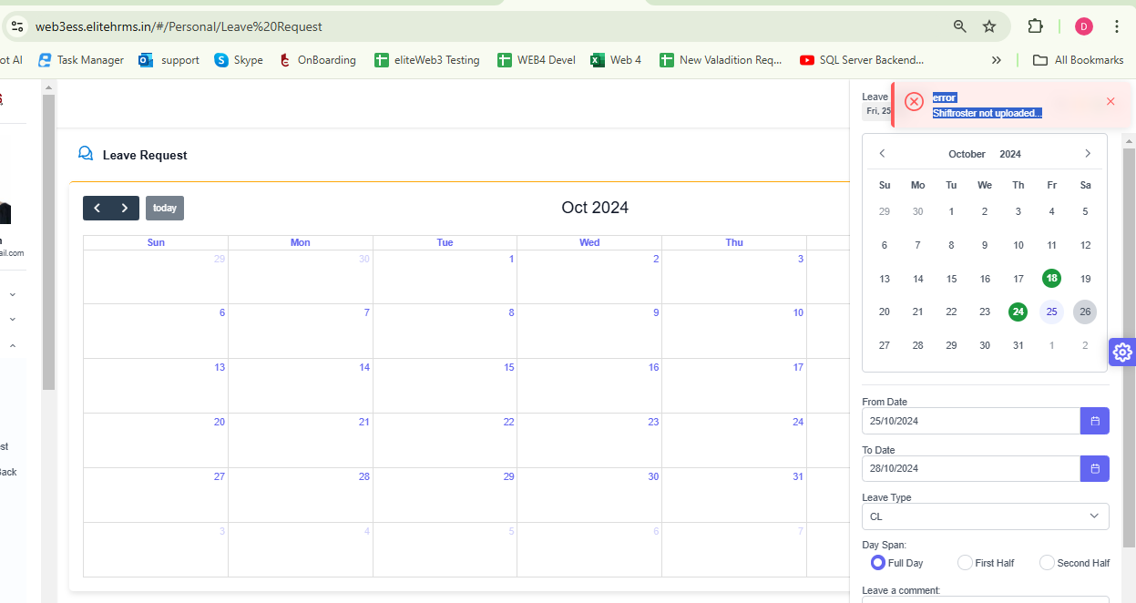

But this Employee Shift Details to show
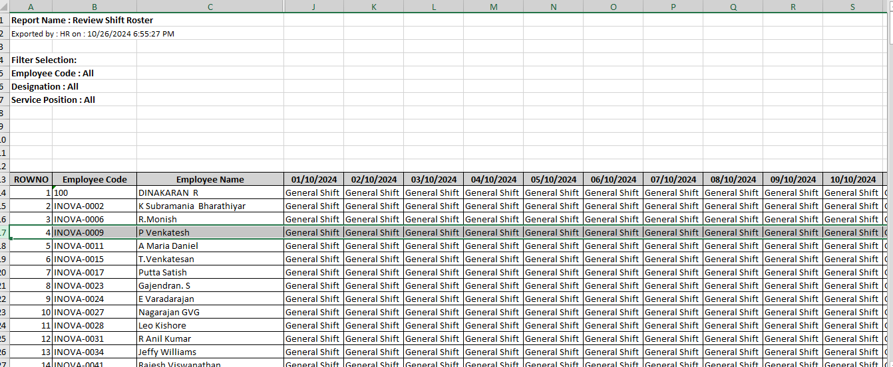

https://web3essapi.elitehrms.in/api/Personal/PostLeaveRequest

authorization:
6dc16508-4df6-4b85-ab46-2d0490dbc298

{"LeaveGUID":"2f8a56aa-1635-f04e-1576-d7bcd1bccbd1","Fromdate":"2024-10-25","Todate":"2024-10-28","LeavetypeID":"2","DaySpanID":"3","Leavestatus":"Draft","Remarks":"test","ScreenID":243}

{
"Response": {
"_status": "Failed",
"_code": "333",
"_Source": "PostLeaveRequest",
"_Description": "Shiftroster not uploaded...",
"_Details": "",
"_TransID": null,
"_Timestamp": "20241026185733"
},
"LeaveDetail": [],
"LeaveBalance": []
}

2.Workflow is Assign But System to show Workflow is not Assign - This issue working fine post leave request issue removed from initial calling
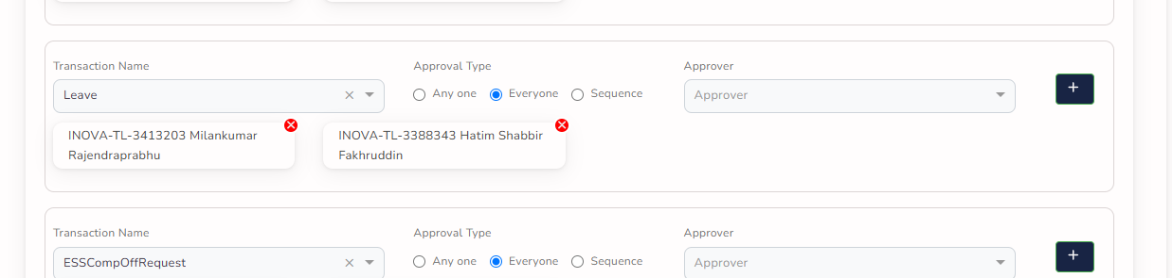
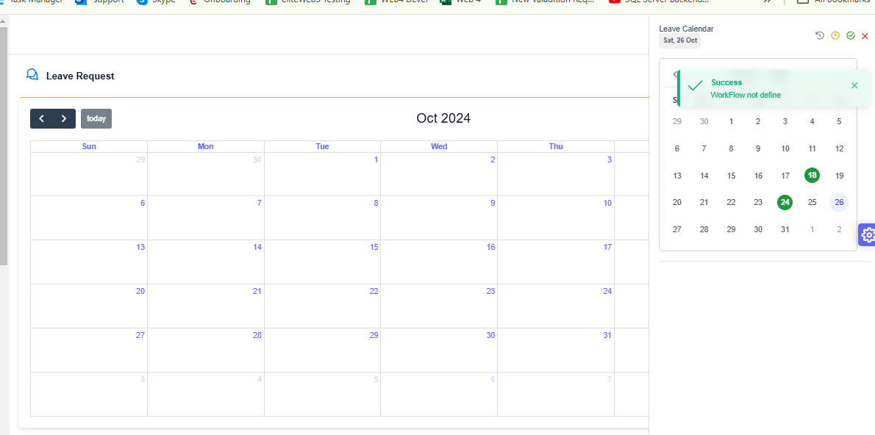

https://web3essapi.elitehrms.in/api/Personal/WorkFlowApprover?ScreenID=243

6f832269-f9f9-42c2-8575-3c67aeac3cb6

ScreenID=243

{
"Response": {
"_status": "Success",
"_code": "111",
"_Source": "GetWorkFlowApprover",
"_Description": "WorkFlow not define",
"_Details": "",
"_TransID": null,
"_Timestamp": "20241026190204"
},
"ScreenID": null,
"WFDefineStatus": true,
"ESIEligibleStatus": false
}

4. AR Request – On duty - Working fine

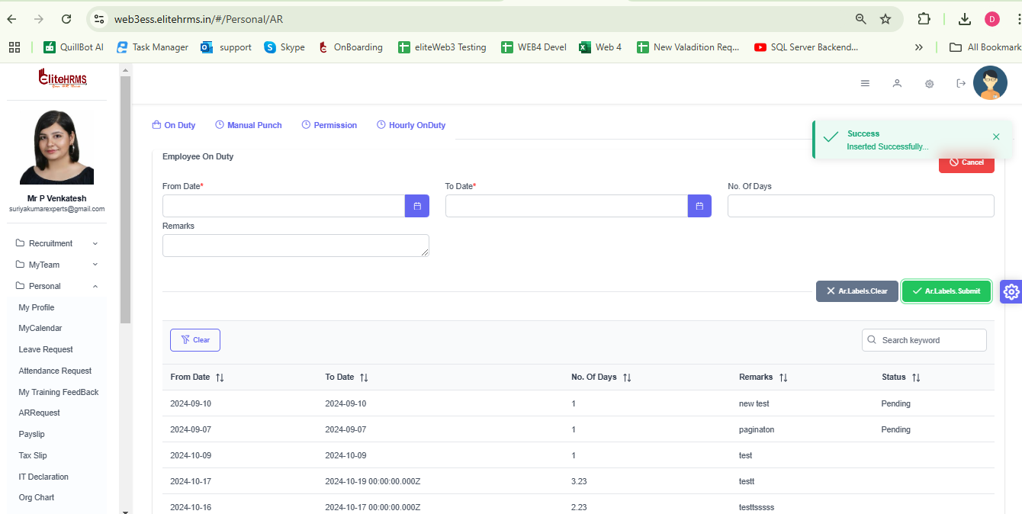

5. AR Request - Manual Punch - Working fine

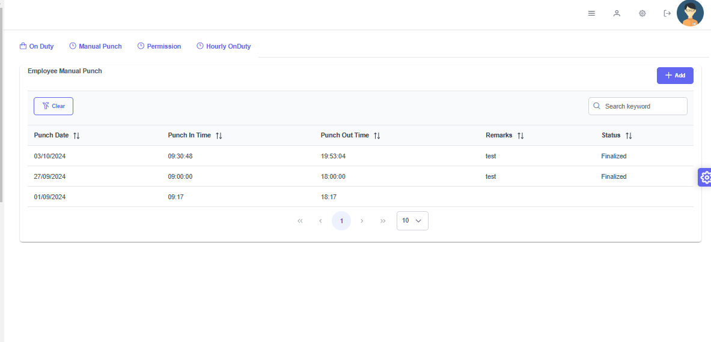

6. AR Request – Permission - Working fine
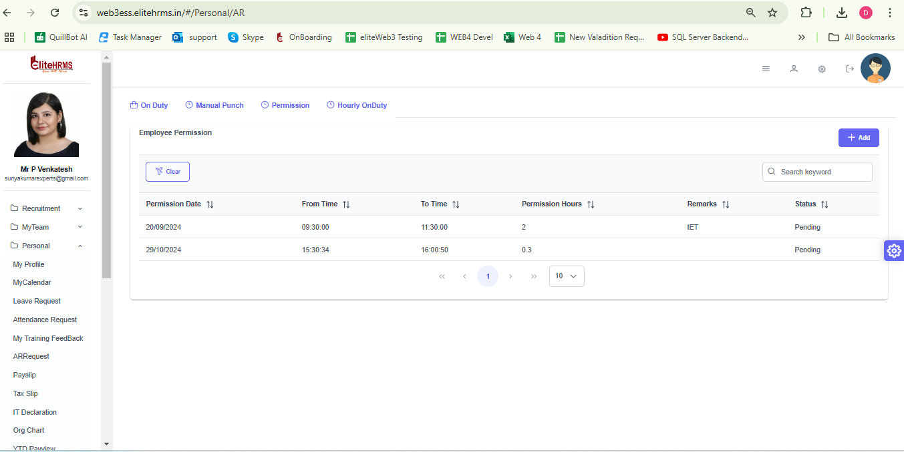

7. AR Request - Hourly On duty – Working fine
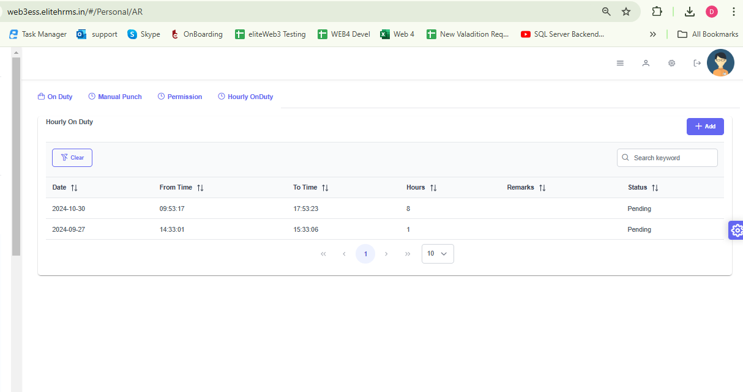

8. Shift Change Request – Fail Inserted new record it is working fine
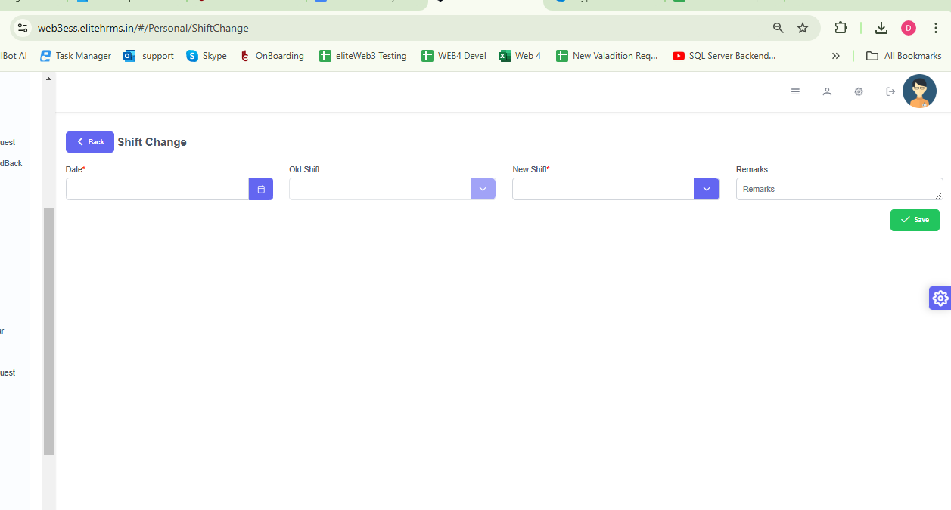

9. New Asset Request – Fail As mentioned in document there is no post for this screen

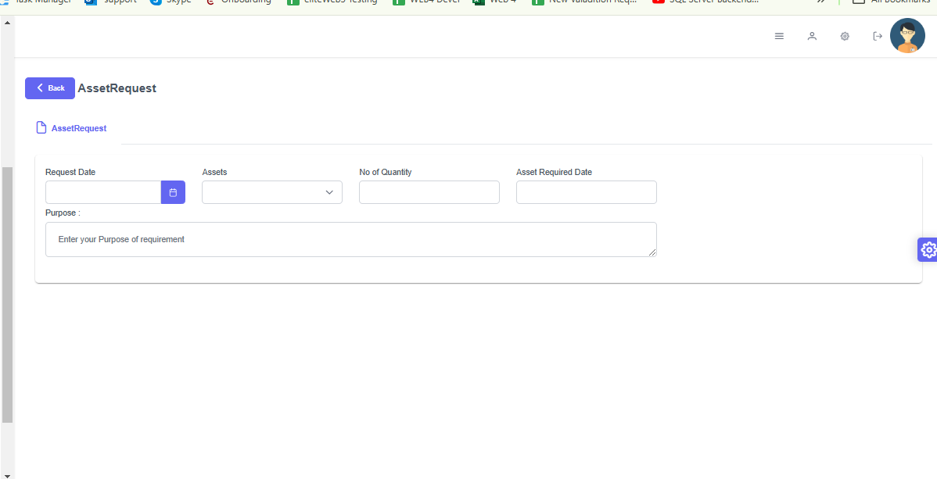

10. My Resignation – Fail record already exist not error
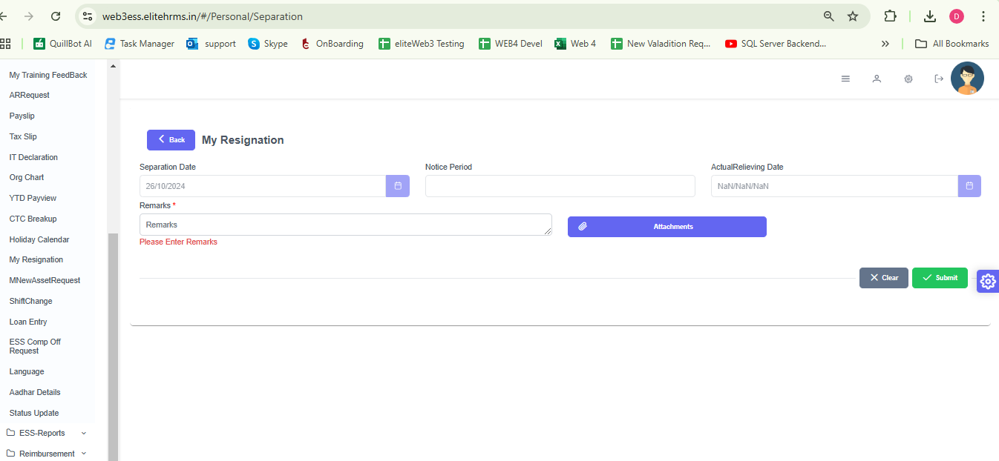

11. Loan Entry Request -
Request successfully but Approval Manager is not Show
